**Building a native extension for Android**

**Attaining User Credentials of User from android device**

**Prerequisites ::**

* Flash Builder 4.7
* AIRSDK 3.6/3.7
* Eclipse with Android SDK

The following document shows you how to create your own AIR native extension for Android.

Here are the following steps to follow for creating “.ane” file and including that in user defined application. Just mentioned in a brief what steps are involved in making native extensions.

### The challenge: Attaining User Credentials from Android Device

The native extensions has the following parts ::

1. Creating native java library.
2. Create Action Script library part.
3. Create an extension.xml file
4. Building the .ane file (AIR native Extension).
5. Embedding the .ane file in an application

**Creating Native JAVA library**

* Create an android project. Don’t create an activity.
* When Project is created, open the project properties and add the AIR extension library **FlashRuntimeExtensions.jar** from AIRSDK\lib\android\FlashRuntimeExtensions.jar (Properties--> Java Build Path-->Add External Jars).
* Create a class Extension class. From the example you can get the class DeviceMailIDExtension.java
* Create a Context Class. DeviceMailIDExtensionContext.java
* Create required number of classes that required which are mentioned in the Context class of getFunctions() method.
* After creating all particular files clean the project from Project tab and create jar file by Exporting the Project. (right click on AndroidProject -->Export) .

**Create Action Script Library**

* Create new Action script library project. (New->Flex Library Project). Include the AIRSDK library
* Fundamentally Action Script Class has two part..

1. Create and Initialize the Context.
2. Call functions in Java Code and return the results

You can get the Class from the example with the name **“DeviceMailIDScriptSample.as”**

* Flash Builder will generates the action script **SWC** file when we perform “Clean” project from project tab if we uncheck the “Build Automatically” option. The SWC file will be created in bin folder.

**Creating extension.xml File**

Create an extension.xml file which contains **platform**, **nativeLibrary** and **initializer** tags. You can get the sample from the above example file “extension.xml”

Platform :: which platform you want to create the ane file .. For this example its “Android-ARM”

nativeLibrary :: Specifies the jar file generated from the native java code(in this example it is AndroidDeviceMailID.jar)

initializer: The class that implements FREExtension (In this example it is “com.example.androiddevicedata.DeviceMailIDExtension”)

**Building the .ane file**

Follow the below structure for creating ane file

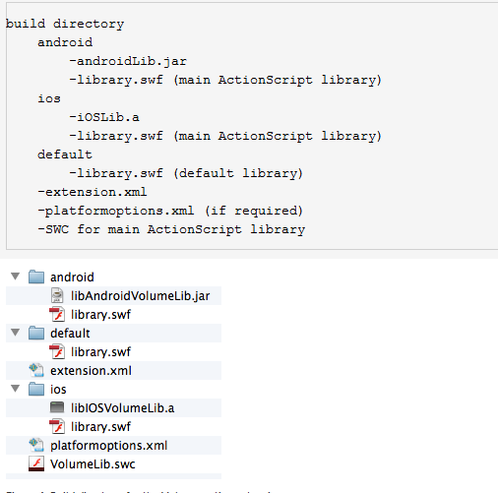

**Note: The library.swf file is inside of the SWC file that the Action Script project generates. Simply extract the contents of the SWC as if it was a ZIP file and you'll see the library.swf file.**

**Command for Creatin ane file is**

adt -package -target ane Output.ane extension.xml -swc VolumeLib.swc -platform iPhone-ARM -C ios . -platformoptions platformoptions.xml -platform Android-ARM -C android . -platform default -C default .

example::

adt -package -target ane mailIDTest.ane extension.xml -swc MailID.swc -platform Android-ARM -C android .

**Embedding the .ane file in an application**

* Create an Action Script Mobile Project (File->New->ActionScriptMobileProject)
* Include the ane file in the actionscriptmobileproject as right click on your mobile project->properties->ActionScript Build Path->Native Extensions tab and then click on AddAne. After adding Click OK.
* Then right click on your mobile project ->properties->ActionScript Build Packaging -> Choose Google Android . In that goto Native Extensions tab and check the ANE Details under Package. Click Apply and OK.
* Now Clean the Project and Connect the Device and debug the application..

The AIR native extension will be included..

**NOTE** :: While including the ANE in actionScript mobile project one thing we need to keep in mind. The xxx-app.xml will be generated in the project if we include the native extension. In that file for this project we need to include the user-permission tag to retrieve the mailID

Example ::

<uses-permission android:name="android.permission.GET_ACCOUNTS/>